Entity Relationship Diagram
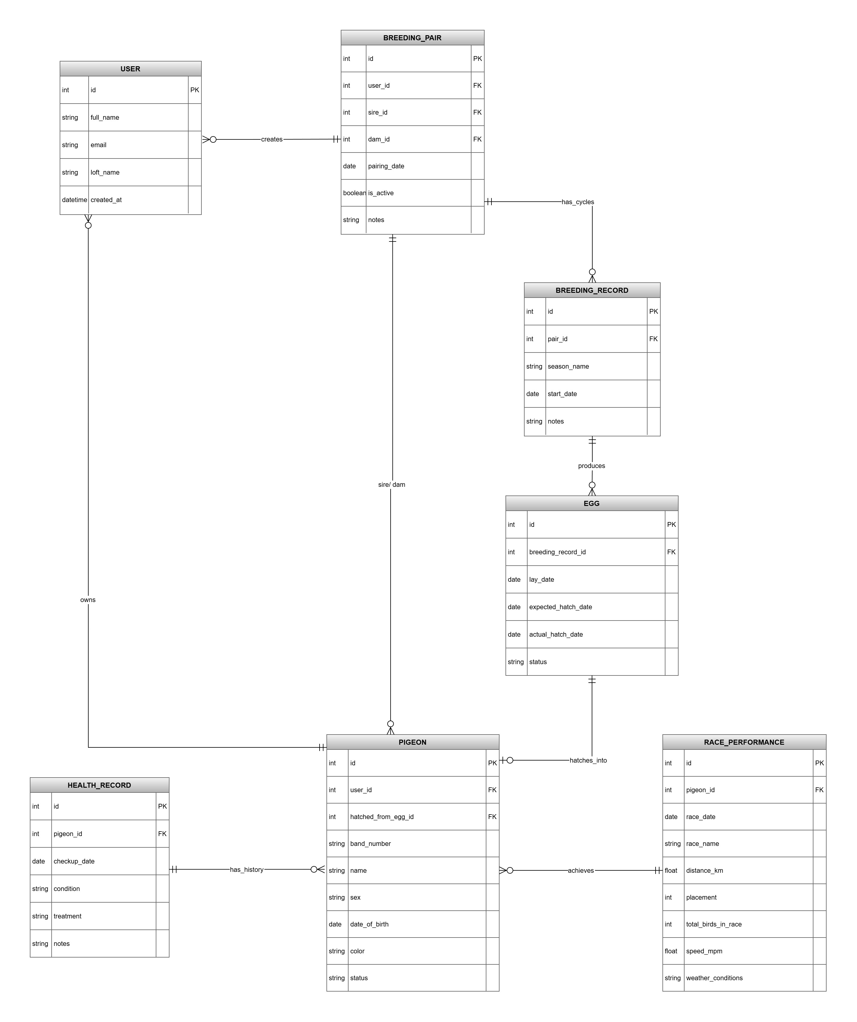
Figure 1: Entity Relationship diagram

Explanation:
The ERD captures the full lifecycle of racing pigeon breeding operation. The USER entity stores breeder account details, while PIGEON represents individual birds, linking them to their owner and, through the hatched_from_egg_id, directly to the egg they came from. BREEDING_PAIR formalises pairing of sire and dam, each referenced by foreign keys. To track nesting cycles, the BREEDING_RECORD entity groups multiple eggs laid by the same pair within a season, and each EGG records lay, expected hatch, and actual hatch dates with a status. Health management is captured by HEALTH_RECORD, which logs check-up events per pigeon, and competitive performance is stored in RACE_PERFORMANCE, documenting placement, speed, and race conditions for individual birds.
Relationships enforce the real-world rules of breeding loft. A USER can own many pigeons and create many breeding pairs, but each pigeon and pair must belong to exactly one user. A BREEDING_PAIR is mandatory linked to one sire and one dam (every pair needs both parents), while a PIGEON can serve as sire or dam across numerous pairs. A pair may have multiple breeding records, and each BREEDING_RECORD can contain several eggs, both relationships are one-to-many from parent to child. An EGG optionally hatches into at most one PIGEON (a zero-or-one relationship), allowing for unhatched eggs. Finally, a PIGEON can accumulate many health records and many race performances, but each health or race entry is tied to exactly one pigeon, creating standard one-to-many multiplicity needed for tracking individual history and achievement.

